CONIC SECTION (ELLIPSE CONCEPT)
A.Two foci concept
B.Major and minor axes
C.Applications (satellite orbits, ship positioning systems, elliptical navigation paths)

INTRODUCTION
An ellipse is a conic section formed when a plane cuts a cone at an angle, but does not intersect the base.
Mathematically, an ellipse is the set of all points in a plane such that:
The sum of distances from two fixed points (called foci) is constant .This constant equals the length of the major axis (2a). In simple words:An ellipse is a stretched circle controlled by two fixed points
PF1+ PF2 = Constant

BASIC DIAGRAM OF AN ELLIPSE
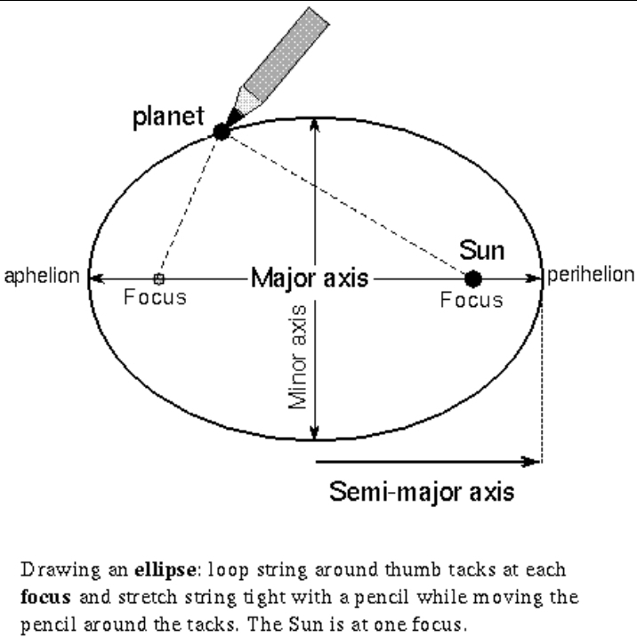

The major components of an Ellipse diagram:
- Center (C),Focus 1 (F₁) ,Focus 2 (F₂) ,Major Axis ,Minor Axis , and Vertices

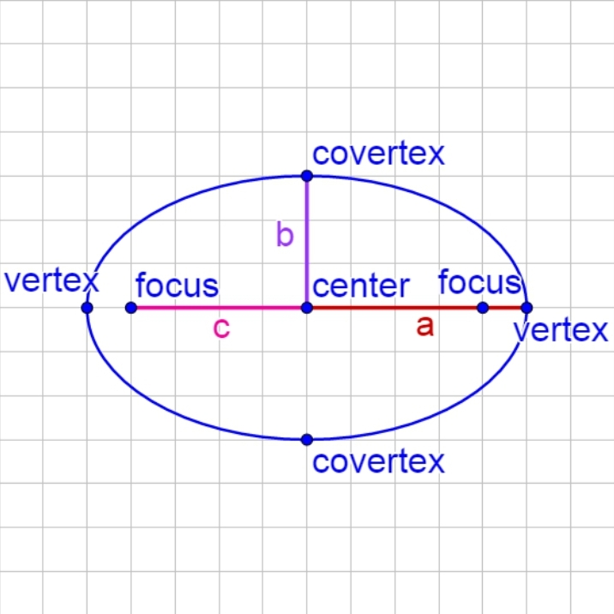
03. TWO FOCI CONCEPT
The ellipse has two fixed points called foci. The key property is:
Distance from F1 + Distance from F2 = Constant.
Let:
- F₁ and F₂ be two fixed points.
- P be any point on the ellipse.
- Then: PF1 + PF2 =constant
This means:If you choose any point on the ellipse, The sum of distances to the two foci remains the same.therefore
Formula for focal distance:
C= √ (a² − b²)
Example:
If a = 10 and b = 8, find distance of each focus from center.
Solution:
c = √(100 − 64) = √36 = 6.
Foci are at (+6,0) and (−6,0).

04. MAJOR AND MINOR AXES
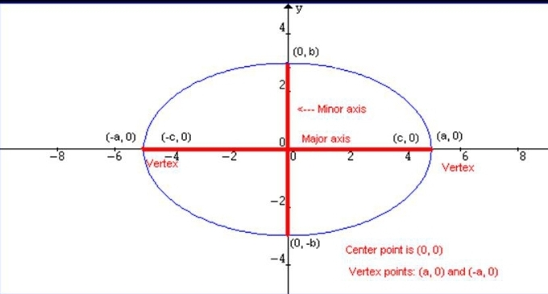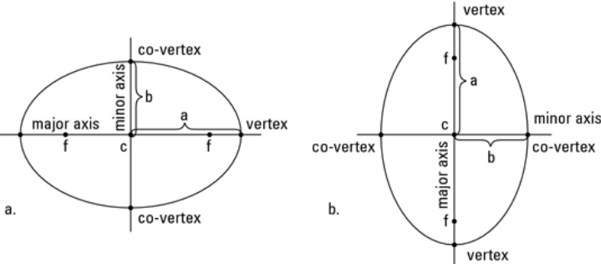
a. Major Axis
- The longest diameter of the ellipse.
- Passes through both foci. Therefor Length = 2a
b.Minor Axis
•The shortest diameter.
•Perpendicular to major axis.Length = 2b
Important Relationship between minor and major is mathematically expressed as
c² = a² -b²
Where:
a = semi-major axis
b = semi-minor axis
c = distance from center to focus
Example:
Given equation x²/25 + y²/9 = 1.requred find lengths of axes.
Solution:
a² = 25 → a = 5
b² = 9 → b = 3
Major axis = 2a = 10
Minor axis = 2b = 6
Therefore the length of axes are 10 and 6 respectively

05. STANDARD EQUATION OF AN ELLIPSE
(i) Horizontal Ellipse
(x- h)²/a² + (y- k)²/b² = 1
(ii) Vertical Ellipse
(x- h)²/b² + (y- k)²/a² = 1
Where:
• (h, k) = cente( a > b)

06. APPLICATIONS OF ELLIPSE
a. Satellite Orbits
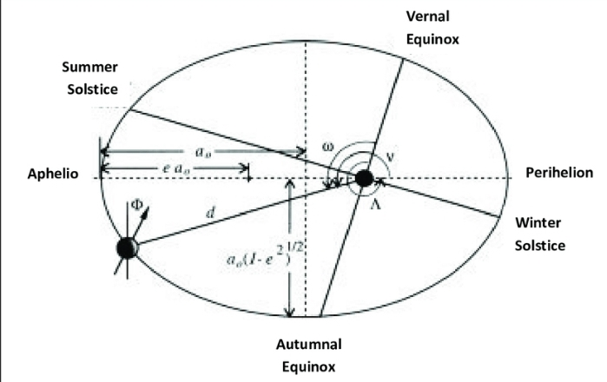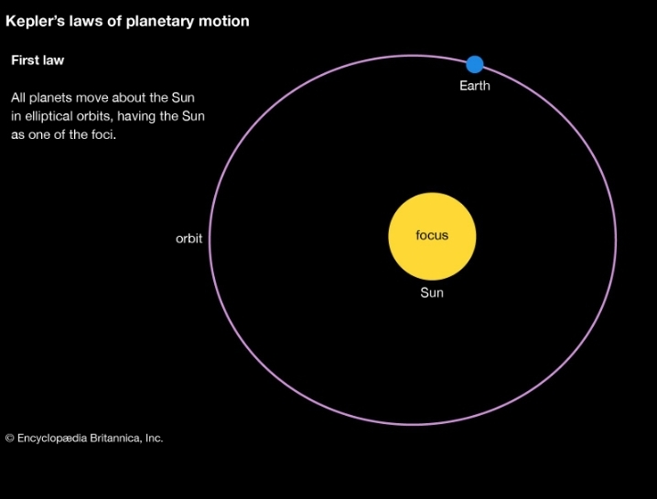
According to Kepler’s First Law ;Planets and satellites move in elliptical orbits with the Earth (or Sun) at one focus.
This explains:
- -Satellite motion
- -GPS satellite positioning
- -Spacecraft trajectories
Example:
A satellite orbit has semi‑major axis 7000 km and semi‑minor axis 6800 km. Find focal distance.
Solution:
c = √(7000² − 6800²)
= √(49,000,000 − 46,240,000)
= √2,760,000≈ 1661 km.
So Earth is 1661 km from center of orbit.
b.Ship Positioning Systems
Some maritime navigation systems use elliptical geometry principles.
If a ship receives signals from two stations, the position can lie along a curve defined by distance relationships — similar to ellipse principles.Used in:
- -Marine tracking
- -Coastal monitoring
- -Position fixing systems
- Engineering systems
Example:
If a ship is 30 km from beacon A and 50 km from beacon B, total distance = 80 km.
All possible ship positions form an ellipse with foci at A and B and constant sum 80 km.
c. Elliptical Navigation Paths
In this field, it is used in:long-distance maritime or aerial navigationas, Travel paths may approximate elliptical arcs.. Ships or aircraft sometimes follow elliptical routes when constrained by winds, currents, or search patterns.Search‑and‑rescue operations often use expanding ellipse patterns
Example
A search aircraft must maintain constant total distance of 200 km from two ground stations 120 km apart.Find semi‑major axis.
Solution:
Total constant = 2a = 200
a = 100 km.

d) Eccentricity
- Eccentricity measures how stretched an ellipse is.
Formula:
e = c/a
If e = 0 → circle
If e close to 1 → very elongated ellipse.
Example:
a = 10, c = 6
e = 6/10 = 0.6

7. General Problem Practice
Problem 1:
Find equation of ellipse with a = 9, b = 4.
Solution:
( x²/81) +( y²/16 )= 1
Problem 2:Find foci of ellipse x²/36 + y²/16 = 1.
Solution:
a² = 36, b² = 16
c = √(36 − 16) = √20 ≈ 4.47
thereforeFoci = (±4.47, 0).

Problem 3:Find the center, vertices, and foci of the ellipse:
(x²/25) + (y²/9) = 1
Solution:
given = Center = (0,0)
a² = 25 → a = 5
b² = 9 → b = 3
c² = a² − b² = 25 − 9 = 16 → c = 4
Vertices = (±5, 0)
therefore Foci = (±4, 0)

Problem 4:Determine whether the ellipse is horizontal or vertical and find its major axis length:
(x²/16) + (y²/36) = 1
Solution:
Largest denominator is under y² → major axis vertical
Major axis length = 2a = 2√36 = 12

Problem 5: Find the equation of an ellipse centered at origin with major axis along x‑axis, a = 6 and b = 4.
Solution:
Standard form: x²/a² + y²/b² = 1
Substitute values:
x²/36 + y²/16 = 1

Problem 6:
Find the foci and eccentricity of the ellipse:( x²/49 ) + ( y²/25 ) = 1
Solution:
a² = 49 → a = 7
b² = 25 → b = 5
c² = a² − b² = 49 − 25 = 24 → c = √24 = 2√6
Foci = (±2√6, 0)
Eccentricity e = c/a = (2√6)/7

Problem 7:Find the equation of an ellipse with center (2, −1), major axis horizontal, a = 5, and passing through point (6,1).
Solution:
Standard form:
(x − h)²/a² + (y − k)²/b² = 1
(x − 2)²/25 + (y + 1)²/b² = 1
Substitute point (6,1):
(6−2)²/25 + (1+1)²/b² = 1
16/25 + 4/b² = 1
4/b² = 1 − 16/25 = 9/25
b² = (4 × 25)/9 = 100/9
Final equation:
(x − 2)²/25 + (y + 1)²/(100/9) = 1
Therefore final equation is(x − 2)²/25 + (y + 1)²/(100/9) = 1
CONCLUSION
the ellipse is not just a geometric curve but a powerful mathematical model with direct application in maritime science and engineering.Mathematically, we have seen that an ellipse is defined by the two-foci concept, where the sum of distances from any point on the curve to the two fixed points (foci) remains constant. Its structure is controlled by the major axis (2a) and minor axis (2b), with the important relationship:
This relationship explains how the shape of the ellipse is formed and how its eccentricity determines whether it is nearly circular or highly elongated.
From a maritime perspective, the ellipse plays a fundamental role in:
- Satellite orbits, as explained by Johannes Kepler, where satellites move in elliptical paths with Earth at one focus.
- Modern navigation systems such as the Global Positioning System, which rely on satellite motion governed by elliptical geometry.
- Ship positioning systems, where distance measurements create elliptical loci to determine accurate vessel location.
- Elliptical navigational and orbital paths used for efficient fuel consumption and long-distance communication systems.
Therefore, understanding the ellipse connects pure mathematics with real maritime technology, including GPS positioning, satellite communication, offshore navigation, and marine forecasting systems.

